Case Study 15: Smart Parking Fee Management

1. Problem Statement
Develop a Python program to manage parking fees in a parking facility. The program should accept the vehicle number, vehicle type, and parking duration, calculate the parking fee based on the vehicle type and duration, and display the final parking bill. The program should also validate user inputs and handle invalid entries.

2. Objectives
To calculate parking fees based on vehicle type and parking duration.
To maintain vehicle parking details
To validate vehicle type and parking hours.
To generate a parking bill automatically.
To reduce manual calculations and improve parking fee management.

3. Assumptions
The vehicle types are two-wheelers, cars, and heavy vehicles.
Parking charges are calculated per hour.
Any part of an hour is charged as one full hour.
Parking duration must be greater than zero.
The following rates are assumed for this academic case study.
Vehicle type | Fee per hour
Two-wheeler | ₹20
Car | ₹40
Heavy vehicle | ₹60
- These are sample rates and may differ from actual parking fees.

4. Algorithm
- Start the program.
- Input the vehicle number.
- Input the vehicle type.
- Input the parking duration in hours.
- Check whether the parking duration is greater than zero.
- If the duration is invalid, display an error message.
- If the vehicle type is a two-wheeler, set the rate to ₹20 per hour.
- If the vehicle type is a car, set the rate to ₹40 per hour.
- If the vehicle type is a heavy vehicle, set the rate to ₹60 per hour.
- If the vehicle type is invalid, display an error message.
- Round the parking duration up to the next whole hour if necessary.
- Calculate the total fee by multiplying the hourly rate by the billable hours.
- Display the vehicle number, vehicle type, parking duration, and total fee.
- Stop the program.

5. Flowchart

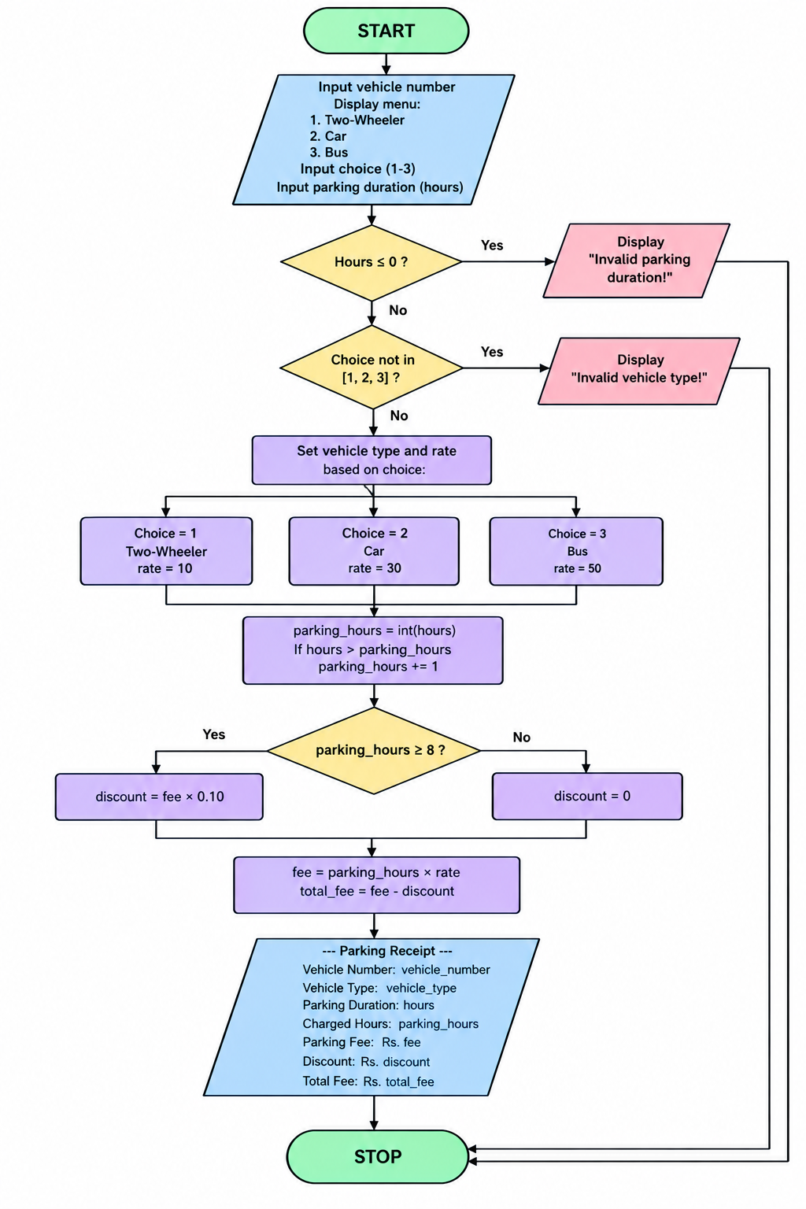

6. Pseudocode
START

INPUT vehicle_number
INPUT vehicle_type
INPUT parking_hours

IF parking_hours <= 0 THEN
DISPLAY "Invalid parking duration"

ELSE
IF vehicle_type = "two-wheeler" THEN
rate = 20
ELSE IF vehicle_type = "car" THEN
rate = 40
ELSE IF vehicle_type = "heavy vehicle" THEN
rate = 60
ELSE
DISPLAY "Invalid vehicle type"
STOP
END IF

billable_hours = ROUND_UP(parking_hours)
fee = rate * billable_hours

DISPLAY vehicle_number
DISPLAY vehicle_type
DISPLAY parking_hours
DISPLAY fee
END IF

STOP

7. Test Cases
Test case | Vehicle type | Duration | Expected output
1 | Two-wheeler | 2 hours | ₹40
2 | Car | 3 hours | ₹120
3 | Heavy vehicle | 4 hours | ₹240
4 | Car | 2.5 hours | ₹120
5 | Two-wheeler | 0 hours | Invalid duration
6 | Bicycle | 2 hours | Invalid vehicle type

8. Output

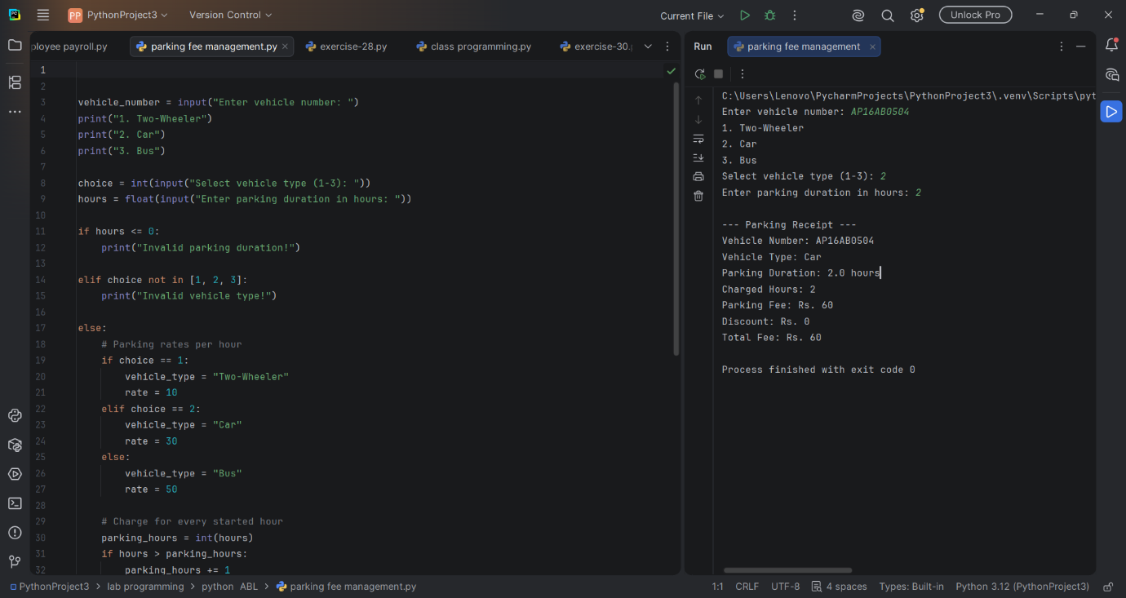

9. Conclusion
The Smart Parking Fee Management program calculates parking charges according to vehicle type and parking duration. It validates inputs, applies the appropriate hourly rate, and generates a parking receipt. This case study demonstrates the use of Python conditional statements, arithmetic operations, input validation, and rounding functions to automate a real-world parking management task.

